

VistA Blood Establishment Computer Software (VBECS) Version 1.6.0

Patch Installation Guide

July 2012

Department of Veterans Affairs
Product Development
This page intentionally left blank.

Unauthorized access or misuse of this system and/or its data is a federal crime. Use of all data must be in accordance with Department of Veterans Affairs (VA) security and privacy policies.
The U.S. Food and Drug Administration (FDA) classifies this software as a medical device. Unauthorized modifications will render this device an adulterated medical device under Section 501 of the Medical Device Amendments to the Federal Food, Drug, and Cosmetic Act. Acquiring and implementing this software through the Freedom of Information Act requires the implementer to assume total responsibility for the software and become a registered manufacturer of a medical device, subject to FDA regulations. Adding to or updating VBECS software without permission is prohibited.

This page intentionally left blank.

Revision History
Date | Revision | Description | Author
05-04-11 | 1.0 | Modified VistA Blood Establishment Computer Software (VBECS) Version 1.5.2, Version 4.0:  Global: Replaced “April 2011” with “May 2011” in the footer.  Global: Replaced “1.5.2” with “1.6.0”.  Global: Replaced “4.0” with “1.0” in the footer.  Global: Replaced “…010311” with” …042911”.  Global: Changed 1.5.2.2 to 1.6.0.3.  Global: Changed 1.5.0 to 1.6.0.  Changed 1.5.0.4 to 1.5.2.2 where applicable.  Global: Changed “Size is 190 MB (200, 054, 059 bytes)” to “Size is 225 MB (236, 807, 224 bytes)”.  Global: Changed “Contains is 396 Files, 45 Folders” to Contains 359 Files, 46 Folders”.  Global: Changed document names from regular font to italics.  Introduction: Deleted section VBECS Version Numbers and Figure 1.  Replaced Figures: 6, 7, 8, 9, 10, 11, 13, 14, 15, 16, 17, 18, 20, 24, 25, 26, 32, 33, 34, 35, 36, 37, 39, 40, 41, 42, 43, 44, 46, 50, 51 and 52.  Download the VBECS 1.6.0.3 Patch File (Test and Prod), Step 7: Changed “Right-click Start, Explorer. In the address window type” to “Open Windows Explorer. In the address field, type”.  Figure 5 and Figure 31: Changed figure captions to “Example of FTP Log In”.  Verify the Contents of the VBECS 1.6.0.3 Patch File (Test and Prod): Moved Step 12 to after Step 9, making it the new Step 10 and renumbering the subsequent steps.  Prerequisites for Installation (Test, Step 5 and Prod, Step 6) – Changed “file extensions on the installation workstation.” to “file extensions on the server.”  Execute VBECS Patch Scripts against the Cluster (Test and Prod), Step 2 – Removed “to initiate the VBECS patch configuration”.  Execute VBECS Patch Scripts against the Cluster (Test and Prod) – In the 1st warning box, removed “Patching the servers will require a reboot.”  Added Section 4 to update configuration files on both cluster nodes for the Test & Prod environments.  Added Section 6 to remove disabled listener services on both cluster nodes for the Test & Prod environments.  Removed sentence and figures VBECS Patch Folder and VBECS Patch Shortcut from section 5 (Test and Prod) and add them to Section 4 (Test and Prod) Step1.  Updated Appendices C, E and F. | BBM team
07-12-11 | 2.0 | Modified VistA Blood Establishment Computer Software (VBECS) Version 1.6.0, Version 1.0:  Global: Changed “May 2011” with “July 2011” in the footer.  Global: Changed “1.0” with “2.0” in the footer.  Global: Changed “…042911” to ” …070711”.  Global: Changed “1.6.0.3” to “1.6.0.4”.  Global: Changed “Size is 225 MB (236, 807, 224” to “Size is 172 MB (180, 399, 566 bytes)”.  Replaced Figures: 4, 7, 8, 9, 10, 13, 18, 20, 24, 25, 26, 30, 33, 34, 35, 36, 40, 44, 46 and 52.  Added “Example of” to figure captions for Figures 6, 8, 9, 13, 14, and 40.  Installation Procedure for the Test and Production Environments: Added message 4th box “Server name representations in the document:  For Region 1 sites; R01YYYNODXXX01, YYY represents the Data Center location (SCR or DVR) and XXX represents the Site Code.  For all other sites; VHAXXXNODZ1, XXX represents the Site Code.”  Download the VBECS 1.6.0.6 Patch File (Test and Prod):  Step 1d; added “or VBECS Patch Installation Record R01YYYCLUXXX01 1.6.0 Test 070809” to the example.  Step 2: Changed “R01XXXNODXX01” to “R01YYYNODXX01”.  Step 5: Changed “R01XXXNODXX02” to “R01YYYNODXX02”.  Step 8: Changed “Windows login ID” to “your_user_name”.  Step 9: Changed “double-click the file” to “click and save the file”.  Step 9: After Figure 6 in Test and Figure 32 in Prod, added a message to refer to Appendix H if download errors are encountered.  Verify the Contents of the VBECS 1.6.0.6 Patch File (Test and Prod):  Step 13: Added “Click OK” to beginning of step.  Executing Patch Script: VBECS Patch Main Script (Test and Prod):  Step 8: Changed “60 minutes” to “30 minutes”.  Step 9 message box: Changed “60 minutes” to “30 minutes”.  Step 16: Revised the example after the bullet list.  Delete Patch Files (Test and Prod): Added a new Step 7 about the LR*5.2”382 patch.  Prerequisite for Installation (Test): Revised Step 2.  Prerequisite for Installation (Prod): Revised Step 3.  Delete Patch Files (Test and Prod), Step 7: Added steps to install VistA patch before proceeding.  Appendix A: Updated the examples.  Appendix G: Added VBECS FTP Download Security Alert.  Added Appendix H: Adding VBECS FTP Site to the Trusted Sites in Internet Explorer. | BBM team
09-06-11 | 3.0 | Modified VistA Blood Establishment Computer Software (VBECS) Version 1.6.0 Patch Installation Guide, Version 2.0:  Global: Changed “July 2011” with “September 2011” in the footer.  Global: Changed “2.0” with “3.0” in the footer.  Global: Changed “…070711” to” …090611”.  Global: Changed “1.6.0.4” to “1.6.0.5”.  Global: Changed “Size is 172 MB (180, 399, 566” to “Size is 173 MB (181, 497, 502 bytes)”.  Global: Removed Note: Active users (users connected to the system through remote desktop) will receive a message indicating the number of minutes they have to complete their work and log out. The patch will not make any system changes during this timeout period.  Global: Changed capturing a screen shot and inserting the screenshot in the appendix with having user check a check box in Appendices E and F  Global: Changed the warning box regarding data conversion with one regarding BCE COTS Interface Configuration.  Added section VBECS 1.6.0 Patch Process Improvements.  In warning boxes, change “After the update” to “During the upgrade”.  Removed Figures 4, 5, 7, 10, 17, 21, 22, 26, 27, 29, 32, 40, 41 and any references to them.  Replaced renumbered Figures: 3, 4, 5, 7, 8, 9, 10, 11, 13, 14, 15, 18, 19, 20, 22, 23, 24, 25, 26 and 27  Installation Procedure for the Test and Production Environment, third caution box, changed "one to two hours of downtime” to “up to 1 hour of downtime”. (Test and Prod)  Download and VBECS 1.6.0.6 Patch File (Test and Prod):  Step 1d, moved “<mmddyy> represents the current date” to before the examples  Deleted steps to verify the C:\temp folder on Server 1 and Server 2.  Step 3, bolded and capitalized Address.  Section Prerequisites for Installation, step 2, added that “VBEC*1*27” must be installed (Test)  Added section: Patching Service Monitor (Test)  Change “Executing Patch Script: VBECS Patch Main Script” to “Executing VBECS Patch: Application Updates”.  Executing VBECS Patch: Application Updates (Test and Prod)  - For Test only: Combined Steps 1 and 2.  - For Prod only: Added sentence and figures VBECS Patch Folder and VBECS Patch Shortcut to Step1.  - For Prod only: Reworked Steps 10, 11 and 12 and renumbered subsequent steps.  - For Prod only: Removed contact information bullet points that do not have to be filled in.  - For Test and Prod: Added steps to verify that all VistA patches are up to date  Section Prerequisites for Installation, step 3, added that “VBEC*1*27” must be installed (Prod)  Removed section to update configuration files on both cluster nodes (Test & Prod).  Removed section to remove disabled listener services on both cluster nodes (Test & Prod).  Updated Appendices A, B, C, E, F and G.  Removed the Notes section. | BBM team
03-12-12 | 4.0 | Modified VistA Blood Establishment Computer Software (VBECS) Version 1.6.0 Patch Installation Guide, Version 3.0:  Global: Changed “September 2011” with “March 2012” in the footer.  Global: Changed “3.0” with “4.0” in the footer.  Global: Changed “…090611” to” …030112”.  Global: Changed “1.6.0.5” to “1.6.0.6”.  Global: Change “OED” to “PD” and “CPS” to “PS”  Global: Changed “Size is 173 MB (181, 497, 502 bytes)” to “Size is 173 MB (182, 180, 076 bytes)”.  Global: Changed “Contains 365 Files, 44 Folders” to “Contains 363 Files, 43 Folders”  Global – Change “c:” to “C:”  Introduction: Changed “VA Veterans Health Administration’s (VHA’s)” to “VA’s”.  Related Manuals and Reference Manuals: Added the VistA Blood Establishment Computer Software (VBECS) 1.6.0 Technical Manual-Security Guide and the VistA Blood Establishment Computer Software (VBECS) Installation Guide.  Prerequisites for Installation (Test and Prod):  Moved from Section 3 to Section 1.  Added steps to download the VBECS Patch Installation Record Form.  Installation Procedure for the Test and Prod Environment, Prerequisites for Installation: Removed instructions to setup detailed folders view.  Installation Procedure for the Test and Prod Environment, Download the VBECS 1.6.0.6 Patch File: Revised step.  Download the VBECS 1.6.0.6 Patch File (Test and Prod): Deleted Step 1.  Deleted steps that describe the location of the log files after patching in the following sections:  Executing the VBECS Patch: Patching Service Monitor.  Executing the VBECS Patch: Application Updates (Test and Prod).  VBECS Patch Installation Record Form for Test.  VBECS Patch Installation Record Form for Production.  Executing the VBECS Patch: Patching Service Monitor: Revised this section.  Executing the VBECS Patch: Application Updates (Test and Prod): Revised this section.  Completing Patch Installation: Added warning box about not configuring interface until BCE COTS is available.  Revised Glossary.  Appendix A (Installation Logs): Revised.  Appendix D (Troubleshooting Messages): Revised.  Deleted Appendix E and changed all references to Appendix E to VBECS Patch Installation Record Form for the Test Environment.  Deleted Appendix F and changed all references to Appendix F to VBECS Patch Installation Record Form for the Production Environment.  Deleted Appendix D: Setup Detailed Folders View.  Renamed Appendix G to the new Appendix D and updated all references to it.  Renamed Appendix H to the new Appendix E and updated all references to it. | BBM team
05/03/12 | 5.0 | Modified VistA Blood Establishment Computer Software (VBECS) Version 1.6.0 Patch Installation Guide, Version 4.0:  Global: Changed “March 2012” with “May 2012” in the footer.  Global: Changed “4.0” with “5.0” in the footer.  Global: Changed “10.3.21.76” to “10.3.9.181”.  Global: Changed “VBECS Patch Installation Record Form for the Test Environment” to “VBECS 1.6.0 Patch Installation Form for the Test Environment”.  Global: Changed “VBECS Patch Installation Record Form for the Production Environment” to “VBECS 1.6.0 Patch Installation Form for the Production Environment”.  Download the VBECS 1.6.0.6 Patch File (Test and Prod), Step 2: Added a note to refer to Appendix D if problems accessing the FTP site are encountered.  Download the VBECS 1.6.0.6 Patch File (Test) – Reworded the bullets the prerequisites bullets.  Updated Figures 1, 2, 3, 22, 23, 24 and 41.  Appendix B: Updated to reflect current information.  Appendix D: Updated fourth row Solution to inform the user to consult the VBECS Technical Manual-Security Guide to correct cluster group issues.  Appendix D: Updated sixth row Error message text. | BBM team
07/27/12 | 6.0 | Modified VistA Blood Establishment Computer Software (VBECS) Version 1.6.0 Patch Installation Guide, Version 5.0:  Global: Changed “May 2012” to “July 2012” in the footer.  Global: Changed “5.0” to “6.0” in the footer.  Global: Changed “…030112” to” …072512”.  Global: Changed “1.6.0.6” to “1.6.0.7”.  Global: Changed “no” to “missing” in pre-filled values steps.  General: Removed Figures 3, 7, 19, 28, 31, 32, 35, and 40.  General: Updated all figures and captions.  General: Combined multiple consecutive warning boxes.  Introduction section, first paragraph, first sentence: Expanded “VBECS” and “VA” acronyms.  Introduction section, second paragraph, first sentence: Expanded “FDA” acronym.  Related Manuals and Reference Materials section: Removed reference to VistA Blood Establishment Computer Software (VBECS) Installation Guide.  Orientation section: Added “Appendices” subsection.  Product Support section: Updated second bullet under “VA Service Desk Alternate Contacts”.  Prerequisites sections (Test and Prod): Removed reference to VistA Blood Establishment Computer Software (VBECS) Installation Guide. (DR 4451)  Prerequisites sections (Test and Prod): Revised all steps.  Download the VBECS 1.6.0.7 Patch File sections (Test and Prod): Revised Step 3.  Executing the VBECS Patch: Patching Service Monitor section: Revised this section.  Executing the VBECS Patch: Application Updates section (Test): Revised Step 5 responding to required VistA patches prompt verification. (DR 4451)  Executing the VBECS Patch: Application Updates sections (Test and Prod): Revised these sections.  Executing the VBECS Patch: Application Updates section (Prod): Revised Step 6 responding to required VistA patches prompt verification. (DR 4451)  Appendix A: Revised.  Appendix C: Reworded Step 2.  Appendix D: Revised.  Appendix E: Revised. | BBM team

This page intentionally left blank.

Table of Contents

Revision History iii
Table of Contents ix
Introduction 1
Related Manuals and Reference Materials 1
Orientation 3
How This Installation Guide Is Organized 3
Appendices 3
Warnings 3
Screen Shots 3
Product Support 3
Problems? 3
VA Service Desk (VASD) Primary Contact 3
Installation Procedure for the Test Environment 5
1 Prerequisites for Installation 5
2 Download the VBECS 1.6.0.7 Patch File 6
3 Verify the Contents of the VBECS 1.6.0.7 Patch File 7
4 Executing the VBECS Patch: Patching Service Monitor 9
5 Executing the VBECS Patch: Application Updates 13
6 Completing Patch Installation 17
Installation Procedure for the Production Environment 19
1 Prerequisites for Installation 19
2 Download the VBECS 1.6.0.7 Patch File 20
3 Verify the Contents of the VBECS 1.6.0.7 Patch File 21
4 Executing the VBECS Patch: Application Updates 23
5 Completing Patch Installation 27
Glossary 29
Appendices 31
Appendix A: Installation Logs 31
Appendix B: Active Directory Server Administrator Groups 33
Appendix C: Instructions for Capturing Screen Shots for Installation Records 37
This page intentionally left blank. 38
Appendix D: Troubleshooting Messages 39
Appendix E: Adding VBECS FTP Site to the Trusted Sites in Internet Explorer 43
Index 47

This page intentionally left blank.
Introduction
The VistA Blood Establishment Computer Software (VBECS) system replaces the previous blood bank software (VistA Blood Bank v5.2) at the Department of Veterans Affairs (VA). The main purpose of VBECS is to automate the daily processing of blood inventory and patient transfusions in a hospital transfusion service.
VBECS is an improved Blood Bank application that facilitates ongoing compliance with Food and Drug Administration (FDA) standards for medical devices and enhances the VA’s ability to produce high-quality blood products and services to veterans. The system follows blood bank standards, standards of national accrediting agencies, FDA regulations, and VA policies.
Unauthorized access or misuse of this system and/or its data is a federal crime. Use of all data must be in accordance with VA security and privacy policies.
The U.S. FDA classifies this software as a medical device. Unauthorized modifications will render this device an adulterated medical device under Section 501 of the Medical Device Amendments to the Federal Food, Drug, and Cosmetic Act. Acquiring and implementing this software through the Freedom of Information Act requires the implementer to assume total responsibility for the software and become a registered manufacturer of a medical device, subject to FDA regulations. Adding to or updating VBECS software without permission is prohibited.

This document describes how server support staff members [Information Resource Management (IRM) or data center personnel] install VBECS. It describes the scripts that must be executed and the arguments that must be supplied. It specifies how to read script output and the actions that must be performed as a result of the output.

VBECS 1.6.0 Patch Process Improvements
The VBECS 1.6.0 patch contains enhancements designed to optimize installation performance and simplify the user experience. The most noticeable of these enhancements includes the automatic population of input fields, reducing the need for typing. In addition to these changes, this patch also uninstalls VBECS Service Monitor and its corresponding group, VBECS GROUP SM from Cluster Administrator. The VBECS Service Monitor is no longer needed due to the services being managed through Cluster Administrator and monitored through Systems Center Operations Manager (SCOM).

Related Manuals and Reference Materials
- VistA Blood Establishment Computer Software (VBECS) 1.6.0 Technical Manual-Security Guide
This page intentionally left blank.

Orientation

How This Installation Guide Is Organized
Maintain the order of the steps for successful installation.
This guide is organized as follows:
See the Installation Procedure for the Test Environment section for installing the test environment.
See the Installation Procedure for the Production Environment section for installing the production environment.

Appendices
See Appendix A: Installation Logs for the location of logs that may be useful in troubleshooting.
See Appendix D: Troubleshooting Messages for examples of troubleshooting messages.

Warnings
Outlined text with a caution icon is used throughout the guide to highlight warnings, limitations, and cautions:
Warnings, limitations, cautions
Read and follow these caution statements and warnings.

Screen Shots
Because VBECS is a medical device, screen shots must be captured at verification points throughout the installation to meet regulatory requirements for objective evidence and documentation.
A (camera) at the beginning of each step that requires a screen capture will identify these points. For more information, see Appendix C: Instructions for Capturing Screen Shots for Installation Records.
Screen shots included in this guide are examples only and may not display actual data.

Product Support

Problems?
Contact your IRM or Laboratory Automated Data Processing Application Coordinator (ADPAC) if you encounter problems and for training support.

VA Service Desk (VASD) Primary Contact
For Information Technology (IT) support, call the VASD, 888-596-HELP (4357) (toll free), 24 hours per day, 7 days per week. [Users with access to the VASD-supported request tool (e.g., Remedy) may file a ticket in lieu of calling the VASD.]

VA Service Desk Alternate Contacts
- During business hours: As an alternate to the toll-free number, call 205-554-4710 (or 205-554-4711 through 205-554-4725), Monday through Friday (excluding holidays), 8:00 a.m. to 7:30 p.m. (Eastern Time).
- Outside business hours: Call 205-554-3459 through 3462 or 3464, 3465, 3475, 3476, or 3482 through 3484 or 708-547-4671 through 4674.
- Web site: http://vaww.itsupportservices.va.gov/vasd_home.asp [VASD]
- Email: vhacionhd@va.gov

Installation Procedure for the Test Environment

Do not deviate from the instructions in this guide.
No users are permitted on the system during the patch installation. Any users on the system at the start of the patch process will be disconnected.
Coordinate the patch installation with the blood bank supervisor. Notify the supervisor that the patch installation requires up to an hour of downtime without interruption.
Server name representations in the document:
For Region 1sites; R01YYYNODXXX01, YYY represents the Data Center location (SCR or DVR) and XXX represents the Site Code.
For all other sites; VHAXXXNODZ1, XXX represents the Site Code.

Prerequisites for Installation
- VBECS 1.5.2.2 is installed and validated.
- VistA patch LR*5.2*382 and VBEC*1*27 (includes LR*5.2*412) must be installed prior to the installation of VBECS 1.6.0 for all functionality to work.
- Verify that there are no active user sessions on the servers.
- Download the VBECS 1.6.0 Patch Installation Form for the Test Environment from either one the following sites:
- VA Software Document Library (VDL) Web site http://www.va.gov/vdl/application.asp?appid=182.
- Documentation is available for the VBECS package on the ANONYMOUS.SOFTWARE directory at one of the following Office of Information (OI) Field Offices. You will be able to utilize documentation in either the ".pdf" or ".doc" format after they extract the .zip file. The preferred method is to File Transfer Protocol (FTP) the files from: download.vista.med.va.gov. This transmits files from the first available FTP server. You may also elect to retrieve documentation directly from a specific server as follows:
- Albany ftp.fo-albany.med.va.gov
- Hines ftp.fo-hines.med.va.gov
- Salt Lake City ftp.fo-slc.med.va.gov
NOTE: The ZIP file listed below will be listed in each of the VBEC and LR patches that are part of the VBECS package and associated patches. It only needs to be downloaded once.
File Name Retrieval format:
VBECS_1_6_0_DOCS_BUNDLE.ZIP BINARY

Download the VBECS 1.6.0.7 Patch File
Prerequisites for VBECS FTP Download:
- The installer must be a server administrator in accordance with Appendix B: Active Directory Server Administrator Groups.
- The installer must be a member of the VBECS Admin AD Group in accordance with Appendix B: Active Directory Server Administrator Groups.

To download the VBECS 1.6.0.7 patch file from the VBECS FTP Site:
- Open a remote desktop connection to the cluster being patched.
- Open Windows Explorer. In the Address field, type ftp://10.3.9.181:20001 (Figure 1) and press Enter. Note: If you encounter problems accessing the FTP site, refer to Appendix D: Troubleshooting Messages.
Figure 1: Connecting to VBECS FTP Site
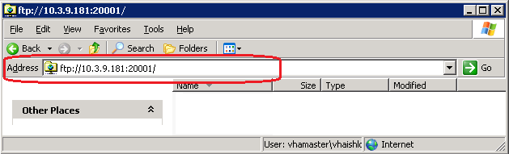
- On the Log On As dialog, enter your domain and NT user name and password (Figure 2).
Figure 2: Example of FTP Log In
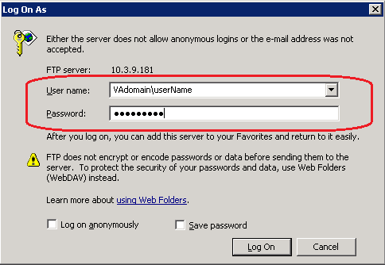
If access problems are encountered, please file a Remedy ticket. Do not proceed until the ticket is resolved.
- Click the Log On button. Right-click the VBECS_Patch_1.6.0.7_072512.zip file and select Copy (** if the VBECS_Patch_1.6.0.7_072512.zip file appears as a link, click and save the file in C:\temp).
If you encounter the 'Your current settings do not allow you to download files from this location' error, see Appendix E: Adding VBECS FTP Site to the Trusted Sites in Internet Explorer for instructions on how to resolve this problem.
- Using Windows Explorer, navigate to the C:\temp folder. Right-click and select Paste. The VBECS_Patch_1.6.0.7_072512.zip file will be copied to this location.

Verify the Contents of the VBECS 1.6.0.7 Patch File
- On the remote desktop connection to the cluster already open, use Windows Explorer to navigate to the C:\temp folder.
- Right-click on the VBECS_Patch_1.6.0.7_072512.zip file and select Extract All.
- After the Extraction Wizard opens, click Next.
- Click Next to extract the contents of the patch zip file to the temp directory.
- After the extraction completes, uncheck Show extracted files and click Finish (Figure 3).
Figure 3: Completing Zip File Extraction
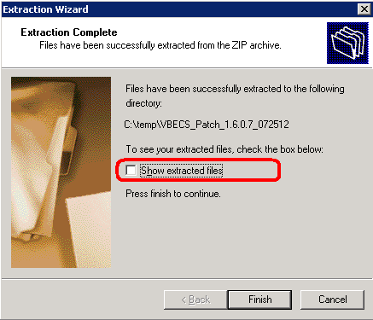
- Verify that the extraction completes and a C:\temp\VBECS_Patch_1.6.0.7_072512 folder is created.
- Using Windows Explorer, right-click on the VBECS_Patch_1.6.0.7_072512 folder and select Properties.
- In the VBECS_Patch_1.6.0.7_072512 Properties window (Figure 4), verify:
  - Size is 173 MB (182, 285, 478 bytes)
  - Contains 363 Files, 43 Folders
If the number of files and number of bytes do not match, stop and file a Remedy ticket. Do not proceed until the ticket is resolved.
- After verifying that the contents of the VBECS_Patch_1.6.0.7_072512 file match, check the box in the VBECS 1.6.0 Patch Installation Form for the Test Environment.
- In the Attributes section, uncheck the Read-only check box (Figure 4).
Figure 4: VBECS Patch Folder Properties
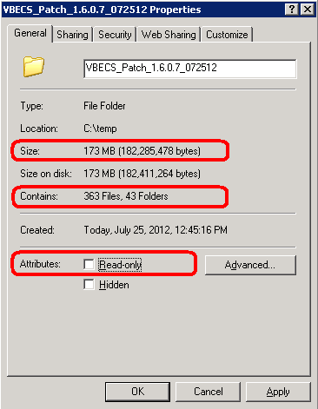
- Capture a screen shot of the VBECS_Patch_1.6.0.7_072512 Properties window.
- Insert the screen shot in the VBECS 1.6.0 Patch Installation Form for the Test Environment.
- Click OK. In the Confirm Attribute Changes window, select the Apply Changes to this folder, subfolders and files option if it is not selected, and click OK (Figure 5).
Figure 5: Removing Read-Only Attributes
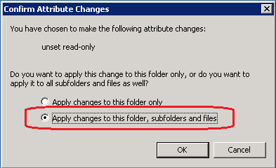
- Using Windows Explorer, navigate to the C:\temp folder.
- Select the VBECS_Patch_1.6.0.7_072512.zip file.
- While holding the Shift key, press the Delete key. Click Yes to confirm file deletion.

Executing the VBECS Patch: Patching Service Monitor
Plan to execute the VBECS patch when no active users are on the servers. The system warns active users that they will be disconnected during the configured timeout period.
During the upgrade, warning emails with the subject ‘Operations Manager Critical Error Alert’ are normal and should be ignored. They are merely noting that changes have been made to the various VBECS files which is expected during a software upgrade.
Do not run any additional applications on the server while the patch is executing.
- On the remote desktop connection to the cluster already open, use Windows Explorer to navigate to the C:\temp\VBECS_Patch_1.6.0.7_072512 folder.
- Double-click the prepare.bat file. Shortcuts for prod, servicemonitor and test are created (Figure 6).
Figure 6: Creating Patch Shortcuts
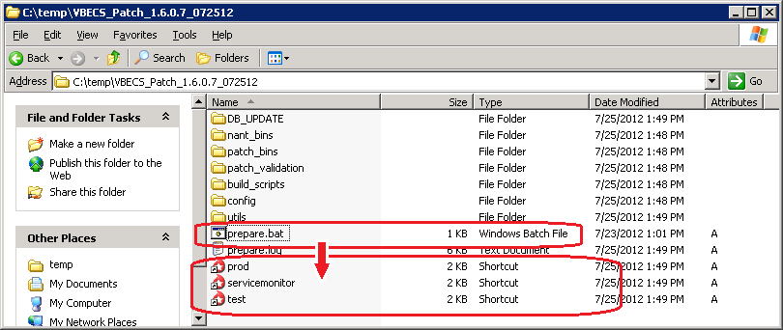
- Double-click on the servicemonitor shortcut.
- The VBECS Patch form will open with the contact information pre-filled for the user applying the patch.
- If the form opens with missing pre-filled values for the contact information, enter the following for the required fields (Figure 7).
- Contact Name – [NAME]: This is your full name.
- Contact E-mail – [E-MAIL]: This is your email address.
- Contact Phone – [PHONE]: This is your telephone number.
Figure 7: Example of VBECS Patch Form : Servicemonitor
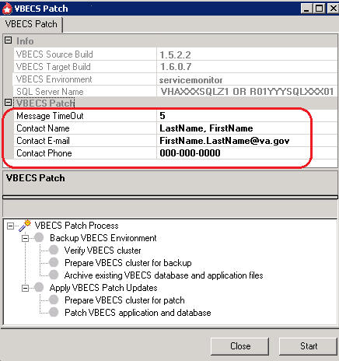
- Click Start.
If the patch detects abnormalities with your system environment, you will be presented with additional screen prompts. Consult Appendix D: Troubleshooting Messages for further information on how to proceed if you encounter a prompt not described in this section.
- The cluster wide patch alert message is displayed. Click OK (Figure 8).
Figure 8: Example of Patch Alert Message
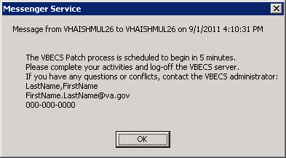
- After the timeout period has expired, a message signifying the final opportunity to abort the patch installation is displayed (Figure 9).
- Click Yes to continue with the patch installation.
- Click No to abort the current patching attempt and restart the patch process at a later time.
Figure 9: VBECS Patch: Continue Patch Message
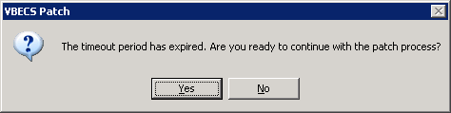
- Refer to Figure 10 for the following:
- A green “patch is working” animation () in the bottom left of the VBECS Patch form will be in motion while the patching is in progress.
- The blue progress bar in the middle of form () will increment based on the overall patch progress.
- VBECS Patch Process checkpoints are displayed in the lower portion of the form. A green check mark indicates that the VBECS Patch process step completed successfully, otherwise a indicates a failure.

If the patch takes longer than 5 minutes to complete the first 3 checks, file a Remedy ticket immediately. Do not release VBECS for use until the ticket is resolved.

If a Patch fails to successfully complete within 10 minutes, file a Remedy ticket immediately. Do not stop the patch process and do not release VBECS for use until the ticket is resolved.
Figure 10: Example of Running VBECS Patch Form : Servicemonitor
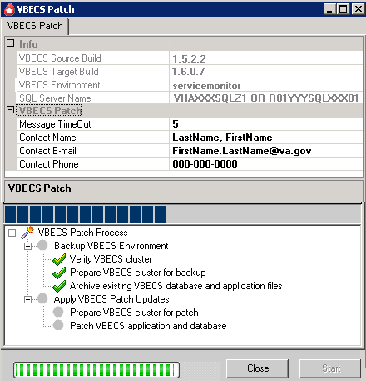
- When the VBECS patch finishes successfully, a “VBECS Patch process completed successfully” message will be received. Check the box in the VBECS 1.6.0 Patch Installation Form for the Test Environment.

If a Patch Failure message is displayed, go to Appendix D: Troubleshooting Messages. If no solution to the failure message is found, please file a Remedy ticket immediately. Do not proceed or release VBECS for use until the ticket is resolved.
By design, there may be non-fatal errors and warnings within the log file output. Ignore warnings and non-fatal errors upon successful completion of the VBECS Patch process.
- Click Close to close the VBECS Patch success message.
- Click Close on the VBECS Patch main window to exit the patch application.

Executing the VBECS Patch: Application Updates
Plan to execute the VBECS patch when no active users are on the servers. The system warns active users that they will be disconnected during the configured timeout period.
During the upgrade, warning emails with the subject ‘Operations Manager Critical Error Alert’ are normal and should be ignored. They are merely noting that changes have been made to the various VBECS files which is expected during a software upgrade.
Do not run any additional applications on the server while the patch is executing.
- On the remote desktop connection to the cluster already open, use Windows Explorer to navigate to the C:\temp\VBECS_Patch_1.6.0.7_072512 folder.
- Double-click the test shortcut. The VBECS Patch form will open with the contact information pre-filled for the user applying the patch.
- If the form opens with missing pre-filled values for the contact information, enter the following for the required fields (Figure 11).
- Contact Name – [NAME]: This is your full name.
- Contact E-mail – [E-MAIL]: This is your email address.
- Contact Phone – [PHONE]: This is your telephone number.
Figure 11: Example of VBECS Patch Form: Test Environment
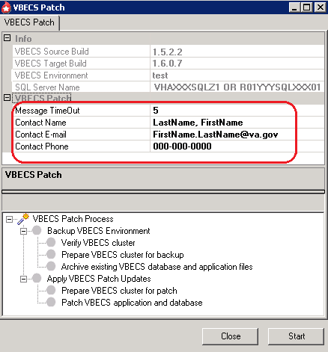
- Click Start.
If the patch detects abnormalities with your system environment, you will be presented with additional screen prompts. Consult Appendix D: Troubleshooting Messages for further information on how to proceed if you encounter a prompt not described in this section.
- A prompt to verify that the required VistA patches are installed is displayed (Figure 12).
- Click Yes to begin the patch installation.
- Click No to abort the current patching attempt and restart the patch process at a later time.
Figure 12: Required VistA Patches Prompt
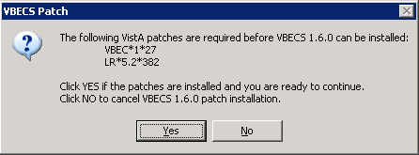
- The cluster wide patch alert message is displayed. Click OK (Figure 13).
Figure 13: Example of Patch Alert Message
- After the timeout period has expired, a message signifying the final opportunity to abort the patch installation is displayed (Figure 14).
- Click Yes to continue with the patch installation.
- Click No to abort the current patching attempt and restart the patch process at a later time.
Figure 14: VBECS Patch: Continue Patch Message
- Refer to Figure 15 for the following:
- A green “patch is working” animation () in the bottom left of the VBECS Patch form will be in motion while the patching is in progress.
- The blue progress bar in the middle of form () will increment based on the overall patch progress.
- VBECS Patch Process checkpoints are displayed in the lower portion of the form. A green check mark indicates that the VBECS Patch process step completed successfully, otherwise a indicates a failure.

If the patch takes longer than 5 minutes to complete the first 3 checks, file a Remedy ticket immediately. Do not release VBECS for use until the ticket is resolved.

If a Patch fails to successfully complete within 30 minutes, file a Remedy ticket immediately. Do not stop the patch process and do not release VBECS for use until the ticket is resolved.
Figure 15: Example of Running VBECS Patch Form: Test Environment
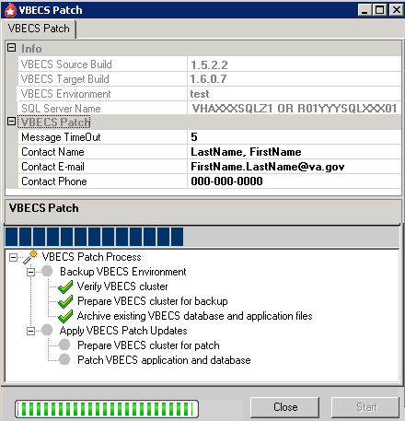
- When the VBECS patch finishes successfully, a “VBECS Patch process completed successfully” message will be received. Check the box in the VBECS 1.6.0 Patch Installation Form for the Test Environment.
If a Patch Failure message is displayed, go to Appendix D: Troubleshooting Messages. If no solution to the failure message is found, please file a Remedy ticket immediately. Do not proceed or release VBECS for use until the ticket is resolved.
By design, there may be non-fatal errors and warnings within the log file output. Ignore warnings and non-fatal errors upon successful completion of the VBECS Patch process.
- Click Close to close the VBECS Patch success message.
- Click Close on the VBECS Patch main window to exit the patch application.

Completing Patch Installation
- On the remote desktop connection to the cluster already open, use Windows Explorer to navigate to the C:\temp folder.
- Select the VBECS_Patch_1.6.0.7_072512 folder.
- While holding down the Shift key, press the Delete key. Click Yes to confirm file deletion.
- Check the box in the VBECS 1.6.0 Patch Installation Form for the Test Environment.
- Print the VBECS 1.6.0 Patch Installation Form for the Test Environment and initial and date the printed copy. Save this with your records of previous VBECS installations.
- Notify the blood bank that the patch has been successfully installed in the Test account and request the blood bank to verify that the Test account can receive orders.

Do not configure the BCE COTS Interface until the Bar Code Expansion commercial off-the-shelf software (BCE COTS) is available.
For BCE COTS Interface Configuration, refer the VistA Blood Establishment Computer Software (VBECS) 1.6.0 Technical Manual-Security Guide (Configure Interfaces section) for Configuration Details.
This page intentionally left blank.
Installation Procedure for the Production Environment

Do not deviate from the instructions in this guide.
No users are permitted on the system during the patch installation. Any users on the system at the start of the patch process will be disconnected.
Coordinate the patch installation with the blood bank supervisor. Notify the supervisor that the patch installation requires up to an hour of downtime without interruption
Server name representations in the document: For Region 1sites; R01YYYNODXXX01, YYY represents the Data Center location (SCR or DVR) and XXX represents the Site Code. For all other sites; VHAXXXNODZ1, XXX represents the Site Code.

Prerequisites for Installation
- VBECS 1.5.2.2 is installed.
- VBECS 1.6.0.7 is installed and validated in the Test environment.
- VistA patch LR*5.2*382 and VBEC*1*27 (includes LR*5.2*412) must be installed prior to the installation of VBECS 1.6.0.7 for all functionality to work.
- Verify that there are no active user sessions on the servers.
- Download the VBECS 1.6.0 Patch Installation Form for the Production Environment from either one the following sites:
- VDL Web site http://www.va.gov/vdl/application.asp?appid=182.
- Documentation is available for the VBECS package on the ANONYMOUS.SOFTWARE directory at one of the following OI Field Offices. You will be able to utilize documentation in either the ".pdf" or ".doc" format after you extract the ZIP file. The preferred method is to FTP the files from: download.vista.med.va.gov. This transmits files from the first available FTP server. You may also elect to retrieve documentation directly from a specific server as follows:
- Albany ftp.fo-albany.med.va.gov
- Hines ftp.fo-hines.med.va.gov
- Salt Lake City ftp.fo-slc.med.va.gov
NOTE: The ZIP file listed below will be listed in each of the VBEC and LR patches that are part of the VBECS package and associated patches. It only needs to be downloaded once.
File Name Retrieval format
VBECS_1_6_0_DOCS_BUNDLE.ZIP BINARY

Download the VBECS 1.6.0.7 Patch File
Prerequisites for VBECS FTP Download:
- The installer must be a server administrator in accordance with Appendix B: Active Directory Server Administrative Groups.
- The installer must be a member of the VBECS Admin AD Group in accordance with Appendix B: Active Directory Server Administrative Groups.

To download the VBECS 1.6.0.7 patch file from the VBECS FTP Site:
- Open a remote desktop connection to the cluster being patched.
- Open Windows Explorer. In the Address field, type ftp://10.3.9.181:20001 (Figure 16) and press Enter. Note: If you encounter problems accessing the FTP site, refer to Appendix D: Troubleshooting Messages.
Figure 16: Connecting to VBECS FTP Site
- On the Log On As dialog, enter your domain and NT user name and password (Figure 17).
Figure 17: Example of FTP Log In
If access problems are encountered, please file a Remedy ticket. Do not proceed until the ticket is resolved.
- Click the Log On button. Right-click the VBECS_Patch_1.6.0.7_072512.zip file and select Copy (** if the VBECS_Patch_1.6.0.7_072512.zip file appears as a link, click and save the file in C:\temp).
If you encounter the 'Your current settings do not allow you to download files from this location' error, see Appendix E: Adding VBECS FTP Site to the Trusted Sites in Internet Explorer for instructions on how to resolve the problem.
- Using Windows Explorer, navigate to the C:\temp folder. Right-click and select Paste. The VBECS_Patch_1.6.0.7_072512.zip file will be copied to this location.

Verify the Contents of the VBECS 1.6.0.7 Patch File
- On the remote desktop connection to the cluster already open, use Windows Explorer to navigate to the C:\temp folder.
- Right-click on the VBECS_Patch_1.6.0.7_072512.zip file and select Extract All.
- After the Extraction Wizard opens, click Next.
- Click Next to extract the contents of the patch zip file to the temp directory.
- After the extraction completes, uncheck Show extracted files and click Finish (Figure 18).
Figure 18: Completing Zip File Extraction
- Verify that the extraction completes and a C:\temp\VBECS_Patch_1.6.0.7_072512 folder is created.
- Using Windows Explorer, right-click on the VBECS_Patch_1.6.0.7_072512 folder and select Properties.
- In the VBECS_Patch_1.6.0.7_072512 Properties window (Figure 19), verify:
  - Size is 173 MB (182, 285, 478 bytes)
  - Contains 363 Files, 43 Folders
If the number of files and number of bytes do not match, stop and file a Remedy ticket. Do not proceed until the ticket is resolved.
- After verifying that the contents of the VBECS_Patch_1.6.0.7_072512 file match, check the box in the VBECS 1.6.0 Patch Installation Form for the Production Environment.
- In the Attributes section, uncheck the Read-only check box (Figure 19).
Figure 19: VBECS Patch Folder Properties
- Capture a screen shot of the VBECS_Patch_1.6.0.7_072512 Properties window.
- Insert the screen shot in the VBECS 1.6.0 Patch Installation Form for the Production Environment.
- Click OK. In the Confirm Attribute Changes window, select the Apply Changes to this folder, subfolders and files option if it is not selected and click OK (Figure 20).
Figure 20: Removing Read-Only Attributes
- Using Windows Explorer, navigate to the C:\temp folder.
- Select the VBECS_Patch_1.6.0.7_072512.zip file.
- While holding the Shift key, press the Delete key. Click Yes to confirm file deletion.

Executing the VBECS Patch: Application Updates
Plan to execute the VBECS patch when no active users are on the servers. The system warns active users that they will be disconnected during the configured timeout period.
After the upgrade, warning emails with the subject ‘Operations Manager Critical Error Alert’ are normal and should be ignored. They are merely noting that changes have been made to the various VBECS files which is expected during a software upgrade.
Do not run any additional applications on the server while the patch is executing.
- On the remote desktop connection to the cluster already open, use Windows Explorer to navigate to the C:\temp\VBECS_Patch_1.6.0.7_072512 folder.
- Double-click the prepare.bat file. Shortcuts for prod, servicemonitor and test are created (Figure 21).
Figure 21: Creating Patch Shortcuts
- Double-click on the prod shortcut. The VBECS Patch form will open with the contact information pre-filled for the user applying the patch.
- If the form opens with missing pre-filled values for the contact information, enter the following for the required fields (Figure 22).
- Contact Name – [NAME]: This is your full name.
- Contact E-mail – [E-MAIL]: This is your email address.
- Contact Phone – [PHONE]: This is your telephone number.
Figure 22: Example of VBECS Patch Form: Production Environment
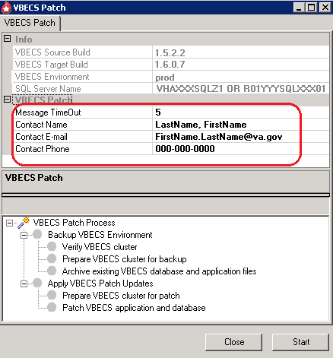
- Click Start.
If the patch detects abnormalities with your system environment, you will be presented with additional screen prompts. Consult Appendix D: Troubleshooting Messages for further information on how to proceed if you encounter a prompt not described in this section.
- A prompt to verify that the required VistA patches are installed is displayed (Figure 23).
- Click Yes to begin the patch installation.
- Click No to abort the current patching attempt and restart the patch process at a later time.
Figure 23: Required VistA Patches Prompt
- The cluster wide patch alert message is displayed. Click OK (Figure 24).
Figure 24: Example of Patch Alert Message
- After the timeout period has expired, a message signifying the final opportunity to abort the patch installation is displayed (Figure 25).
- Click Yes to continue with the patch installation.
- Click No to abort the current patching attempt and restart the patch process at a later time.
Figure 25: VBECS Patch: Continue Patch Message
- Refer to Figure 26 for the following:
- A green “patch is working” animation () in the bottom left of the VBECS Patch form will be in motion while the patching is in progress.
- The blue progress bar in the middle of form () will increment based on the overall patch progress.
- VBECS Patch Process checkpoints are displayed in the lower portion of the form. A green check mark indicates that the VBECS Patch process step completed successfully, otherwise a indicates a failure.

If the patch takes longer than 5 minutes to complete the first 3 checks, file a Remedy ticket immediately. Do not release VBECS for use until the ticket is resolved.

If a Patch fails to successfully complete within 30 minutes, file a Remedy ticket immediately. Do not stop the patch process and do not release VBECS for use until the ticket is resolved.
Figure 26: Example of VBECS Patch Form: Production Environment
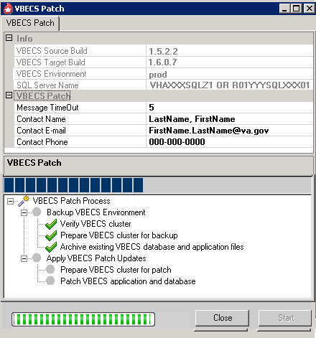
- When the VBECS patch finishes successfully, a “VBECS Patch process completed successfully” message will be received. Check the box in the VBECS 1.6.0 Patch Installation Form for the Production Environment.

If a Patch Failure message is displayed, go to Appendix D: Troubleshooting Messages. If no solution to the failure message is found, please file a Remedy ticket immediately. Do not proceed or release VBECS for use until the ticket is resolved.

By design, there may be non-fatal errors and warnings within the log file output. Ignore warnings and non-fatal errors upon successful completion of the VBECS Patch process.
- Click Close to close the VBECS Patch success message.
- Click Close on the VBECS Patch main window to exit the patch application.

Completing Patch Installation
- On the remote desktop connection to the cluster already open, use Windows Explorer to navigate to the C:\temp folder.
- Select the VBECS_Patch_1.6.0.7_072512 folder.
- While holding down the Shift key press the Delete key. Click Yes to confirm file deletion.
- Check the box in the VBECS 1.6.0 Patch Installation Form for the Production Environment.
- Print the VBECS 1.6.0 Patch Installation Form for the Production Environment and initial and date the printed copy. Save this with your records of previous VBECS installations.
- Notify the blood bank that the patch has been successfully installed in the Production account and request the blood bank to verify that the Production account can receive orders.
Do not configure the BCE COTS Interface until the Bar Code Expansion commercial off-the-shelf software (BCE COTS) is made available.
For BCE COTS Interface Configuration, refer the VistA Blood Establishment Computer Software (VBECS) 1.6.0 Technical Manual-Security Guide (Configure Interfaces section) for Configuration Details
This page intentionally left blank.
Glossary

Acronym, Term | Definition
AD | Active Directory.
ADPAC | Automated Data Processing Application Coordinator.
BCE | Bar Code Expansion.
COTS | Commercial Off-the-Shelf Software.
FDA | Food and Drug Administration.
FTP | File Transfer Protocol
IT | Information Technology.
OI | Office of Information.
PD | Product Development.
PS (formerly CPS, formerly EPS) | Product Support.
IRM | Information Resource Management.
Remote Desktop Connection (formerly Terminal Services) | The connectivity tool used to access VBECS on the server.
SCOM | Systems Center Operations Manager.
VA | Department of Veterans Affairs.
VASD | VA Service Desk.
VBECS | VistA Blood Establishment Computer Software.
VDL | VA Software Document Library.
Veterans Health Information Systems and Technology Architecture (VistA) | Formerly the Decentralized Hospital Computer Program (DHCP) of the Veterans Health Administration (VHA), Department of Veterans Affairs (VA). VistA software, developed by the VA, is used to support clinical and administrative functions at VA Medical Centers nationwide. It is written in M and, via the Kernel, runs on all major M implementations regardless of vendor. VistA is composed of packages that undergo a verification process to ensure conformity with name spacing and other VistA standards and conventions.

This page intentionally left blank.

Appendices

Appendix A: Installation Logs
Parts of the installation produce logs, which can help resolve installation issues. The logs and their locations are as follows:
- When the patch is executed for the Service Monitor environment, a log file will be created in:
  - C:\Program Files\VistA\Archive\logs
  - L:\VBECS_Archive\VBECSRecords directories with <ACTIVENODE>_VBECS_<mmddyy>_1.5.2.2_to_1.6.0.7_servicemonitor_<hhmm>.log as the file name, where:
    - <ActiveNode> represents the active cluster node at the time of patch execution.
    - <mmddyy> represents the current date.
    - <hhmm> represents the hour and minute the patch began execution.
For example, VHAXXXNODZ1_VBECS_090111_1.5.2.2_to_1.6.0.7_servicemonitor_1610.log or R01YYYNODXXX01_VBECS_090111_1.5.2.2_to_1.6.0.7_servicemonitor_1610.log.

- When the patch is executed for the Test environment, a log file will be created in:
  - C:\Program Files\VistA\Archive\logs
  - L:\VBECS_Archive\VBECSRecords directories, with <ACTIVENODE>_VBECS_<mmddyy>_1.5.2.2_to_1.6.0.7_test_<hhmm>.log as the file name, where:
    - <ActiveNode> represents the active cluster node at the time of patch execution.
    - <mmddyy> represents the current date.
    - <hhmm> represents the hour and minute the patch began execution.
For example, VHAXXXNODZ1_VBECS_090111_1.5.2.2_to_1.6.0.7_test_1610.log or
R01YYYNODXXX01_VBECS_090111_1.5.2.2_to_1.6.0.7_test_1610.log.

- When the patch is executed for the Prod environment, a log file will be created in:
  - C:\Program Files\VistA\Archive\logs
  - L:\VBECS_Archive\VBECSRecords directories, with <ACTIVENODE>_VBECS_<mmddyy>_1.5.2.2_to_1.6.0.7_prod_<hhmm>.log as the file name, where:
    - <ActiveNode> represents the active cluster node at the time of patch execution.
    - <mmddyy> represents the current date.
    - <hhmm> represents the hour and minute the patch began execution.
For example, VHAXXXNODZ1_VBECS_090111_1.5.2.2_to_1.6.0.7_prod_1610.log or
R01YYYNODXXX01_VBECS_090111_1.5.2.2_to_1.6.0.7_prod_1610.log.
This page intentionally left blank.

Appendix B: Active Directory Server Administrator Groups
Each site has two user groups in Active Directory (VHA.med.va.gov\VBECS\VBECS Users) that support VBECS. Members of the administrative group can access the administrative component of VBECS. Members of the user group can access functional components of VBECS. Multidivisional sites share groups. Table 1 lists all group names.
Table 1: Group Names
VISN | Facility # | Facility | Server Administrative Group | VBECS Admin AD Group
1 | 523 | Boston (Boston HCS) | VHABHS VBECS Server Admins | vhaBHS Vbecs Administrators
1 | 608 | Manchester | vhaMANVbecsServerAdmins | vhaMANVbecsAdministrators
1 | 631 | Northampton | vhaNHMVbecsServerAdmins | vhaNHMVbecsAdministrators
1 | 650 | Providence | vhaPROVbecsServerAdmins | vhaPROVbecsAdminstrators
1 | 402 | Togus | VHATOGVBECS Administrators | vhaTOGVbecs Administrators
1 | 689 | West Haven (Connecticut HCS) | vhaCONVbecsServerAdmins | vhaCONVbecsAdministrators
1 | 405 | White River Junction | vhaWRJVbecsServerAdmins | vhaWRJVbecsAdministrators
2 | 528A8 | Albany (Upstate New York HCN) MC | vhaUNYVbecsServerAdmins | vhaUNYVbecsAdministrators
2 | 528A6 | Bath (Upstate New York HCN) | vhaUNYVbecsServerAdmins | vhaUNYVbecsAdministrators
2 | 528 | Buffalo (Upstate New York HCN) | vhaUNYVbecsServerAdmins | vhaUNYVbecsAdministrators
2 | 528A5 | Canandaigua VA Medical Center | vhaUNYVbecsServerAdmins | vhaUNYVbecsAdministrators
2 | 528A7 | Syracuse (Upstate New York HCS) | vhaUNYVbecsServerAdmins | vhaUNYVbecsAdministrators
3 | 526 | Bronx | vhaBRXVbecsServerAdmins | vhaBRXVbecsAdministrators
3 | 620A4 | Castle Point (Hudson Valley HCS) | vhaHVHVbecsServerAdmins | vhaHVHVbecsAdministrators
3 | 561 | East Orange (New Jersey HCS) | vhaNJHVbecsServerAdmins | vhaNJHVbecsAdministrators
3 | 630 | New York (New York Harbor HCS) New York | vhaNYHVbecsServerAdmins | vhaNYHVbecsAdministrators
3 | 630A4 | New York (New York Harbor HCS) Brooklyn | vhaNYHVbecsServerAdmins | vhaNYHVbecsAdministrators
3 | 632 | Northport | vhaNOPVbecsServerAdmins | vhaNOPVbecsAdminstrators
4 | 503 | Altoona | VHAALTVbecsServerAdm | vhaALTVbecsAdministrators
4 | 540 | Clarksburg | vhaCLAVbecsServerAdmins | vhaCLAVbecsAdministrators
4 | 542 | Coatesville | VHACOAVbecsAdministrators | vhaCOAVbecsAministrators
4 | 562 | Erie | vhaERIVbecsServerAdmins | vhaERIVbecsAdministrators
4 | 595 | Lebanon | VHALEBVbecsServerAdministrators | vhaLEBVbecsAdministrators
4 | 642 | Philadelphia | vhaPHIVBECS_ADM | vhaPhiladelphiaBBAdmin
4 | 646 | Pittsburgh University Drive (Pittsburgh HCS) | vhaPTHVbecsServerAdmins | vhaPTHVbecsAdministrators
4 | 693 | Wilkes-Barre | vhaWBPVbecsServerAdmins | vhaWBPVbecsAdministrators
4 | 460 | Wilmington | VHAWIMVbecsServerAdministrators | vhaWIMVbecsAdministrators
5 | 512 | Baltimore (Maryland HCS) | vhaBALVbecsServerAdmin | vhaBALVbecsAdministrators
5 | 512A5 | Perry Point (Maryland HCS) | vhaBALVbecsServerAdmin | vhaBALVbecsAdministrators
5 | 613 | Martinsburg | vhaMWVVbecsServerAdmin | vhaMWVVbecsAdministrators
5 | 688 | Washington | VHAWAS VBECS Administrators | vhaWAS Vbecs Administrators
6 | 637 | Asheville | vhaASHVbecsServerAdmins | vhaASHVbecsAdministrators
6 | 517 | Beckley | vhaBECVbecsServerAdmins | vhaBECVbecsAdministrators
6 | 558 | Durham | vhaDURAdmin | v06DURVbecsAdministrators
6 | 565 | Fayetteville NC | vhaFNCVbecsServerAdmins | vhaFNCVbecsAdministrators
6 | 590 | Hampton | vhaHAMVbecsServerAdmins | vhaHAMVbecsAdministrators
6 | 652 | Richmond | vhaRICVbecsServerAdmins | vhaRICVbecsAdministrators
6 | 658 | Salem | vhaSAMVbecsServerAdmins | vhaSAMVbecsAdmins
6 | 659 | Salisbury (Heffner) | VSBYVbecsAdministrators | vhaSBYVbecsAdministrators
7 | 508 | Atlanta | vhaATGVbecsServerAdmins | vhaATGVbecsAdministrators
7 | 509 | Augusta | vhaAUGVbecsServerAdmins | vhaAUGVbecsAdministrators
7 | 521 | Birmingham MC | vhaBIRVbecsServerAdmins | vhaBIRVbecsAdministrators
7 | 534 | Charleston | vhaCHAVbecsServerAdmins | vhaCHAVbecsAdministrators
7 | 544 | Columbia SC | vhaCMSVbecsServerAdmins | vhaCMSVbecsAdministrators
7 | 557 | Dublin | vhaDUBVbecsServerAdmins | vhaDUBVbecsAdministrators
7 | 619 | Montgomery (Central Alabama HCS) | vhaCAVVbecsServerAdmins | vhaCAVVbecsAdministrators
7 | 619A4 | Tuskegee (Central Alabama HCS) | vhaCAVVbecsServerAdmins | vhaCAVVbecsAdministrators
8 | 516 | Bay Pines MC | vhaBAYVbecsServerAdmins | vhaBAYVbecsAdministrators
8 | 573 | Gainesville (N Florida/S Georgia HCS) | vhaNFL VbecsServerAdmins | VHANFL SP VbecsAdministrators
8 | 573A4 | Lake City (N Florida/S Georgia HCS) | vhaNFL VbecsServerAdmins | VHANFL SP VbecsAdministrators
8 | 672 | San Juan | vhaSAJVbecsServerAdmins | vhaSAJVbecsAdministrators
8 | 546 | Miami | vhaMIAVbecsServerAdmins | vhaMIAVbecsAdministrators
8 | 673 | Tampa | vhaTAMVbecsServerAdmins | vhaTAMVbecsAdministrators
8 | 548 | West Palm Beach | vhaWPBVbecsServerAdmins | vhaWPBVbecsAdministrators
9 | 581 | Huntington | vhaHUNVbecsServerAdmins | vhaHUNVbecsAdministrators
9 | 596 | Lexington | vhaLEXVbecsServerAdmins | vhaLEXVbecsAdministrators
9 | 603 | Louisville | vhaLOUVbecsServerAdmins | vhaLOUVbecsAdministrators
9 | 614 | Memphis | vhaMEMVbecsServerAdmins | vhaMEMVbecsAdministrators
9 | 621 | Mountain Home | vhaMOUVbecsServerAdmins | vhaMOUVbecsAdministrators
9 | 626 | Nashville (Tennessee Valley HCS) | vhaTVHVbecsServerAdmins | vhaTVHVbecsAdministrators
9 | 626A4 | Murfreesboro (Tennessee Valley HCS) | vhaTVHVbecsServerAdmins | vhaTVHVbecsAdministrators
10 | 538 | Chillicothe | vhaCLLVbecsServerAdmins | vhaCLLVbecsAdministrators
10 | 539 | Cincinnati | vhaCINAdmin | v10CinVbecsAdministrators
10 | 541 | Cleveland Wade Park | vhaCLEVbecsServerAdmins | vHACLEVbecsAdministrators
10 |  | Columbus | v10COSVbecsServerAdmins | v10COSVbecsAdministrators
10 | 552 | Dayton | vhaDAYVbecsServerAdmins | vhaDAYVbecsAdministrators
11 | 506 | Ann Arbor | vhaANN_VbecsServerAdmins | vhaANN_VbecsAdministrators
11 | 515 | Battle Creek | vhaBACVbecsServerAdmins | vhaBACVbecsAdministrators
11 | 550 | Danville (Illiana HCS) | vhaDANVbecsServerAdmins | vhaDANVbecsAdministrators
11 | 553 | Detroit Allen Park | vhaDETVbecsServerAdmins | vhaDETVbecsAdministrators
11 | 610 | Marion IN (Northern Indiana HCS) | vhaNINVbecsServerAdmins | VhaNinVbecsAdministrators
11 | 610A4 | Fort Wayne (Northern Indiana HCS) | vhaNINVbecsServerAdmins | VhaNinVbecsAdministrators
11 | 583 | Indianapolis | vhaIND_VBECS_ADMIN | vhaIindianapolisBBAdmin
11 | 655 | Saginaw | vhaSAGVbecsServerAdmin | vhaSAGVbecsAdmin
12 | 537 | Chicago Westside (Chicago HCS) | v12CHSVbecsServerAdmins | v12CHSVbecsAdministrators
12 | 578 | Hines VA Hospital | v12HINVbecsServerAdmins | v12HINVbecsAdministrators
12 | 585 | Iron Mountain | vhaIROVbecsServerAdmins | vhaIROVbecsAdministrators
12 | 607 | Madison | v12MADVbecsServerAdmins | v12MADVbecsAdministrators
12 | 695 | Milwaukee | v12MIWVbecsServerAdmins | v12MIWVbecsAdministrators
12 | 556 | North Chicago | v12NCHVbecsServerAdmins | v12NCHVbecsAdministrators
12 | 676 | Tomah | vhaTOMVbecsServerAdmins | vhaTOMVbecsAdministrators
15 | 589 | Kansas City (Heartland West HCS) | v15KANVbecsAdministrators | v15KANVbecsAdministrator
15 | 589A4 | Columbia MO (Heartland West HCS) | v15KANVbecsAdministrators | v15KANVbecsAdministrator
15 | 589A5 | Topeka (Eastern Kansas HCS) | v15KANVbecsAdministrators | v15KANVbecsAdministrator
15 | 589A6 | Leavenworth (Eastern Kansas HCS) | v15KANVbecsAdministrators | v15KANVbecsAdministrator
15 | 589A7 | Wichita | v15KANVbecsAdministrators | v15KANVbecsAdministrator
15 | 657 | St. Louis (Heartland East HCS) | STL VBECS Server Administration | EasternOrbitVbecsAdmin
15 | 657A4 | Poplar Bluff (Heartland East HCS) | STL VBECS Server Administration | EasternOrbitVbecsAdmin
15 | 657A5 | Marion IL | STL VBECS Server Administration | EasternOrbitVbecsAdmin
16 | 502 | Alexandria | V16ALXVbecsServerAdmins | vhaALXVbecsAdministrators
16 | 520 | Biloxi (VA Gulf coast HCS) | v16BILVbecsServerAdmins | v16BILVbecsAdministrators
16 | 564 | Fayetteville AR | v16FAVVbecsServerAdmins | v16FAVVbecsAdministrators
16 | 580 | Houston | vhaHOUVbecsServerAdmins | vhaHOUVbecsAdministrators
16 | 586 | Jackson | v16JACVbecsServerAdmins | v16JACVbecsAdministrators
16 | 598 | Little Rock (Central AR Veterans HCS) | v16LITVbecsServerAdmins | v16LITVbecsAdministrators
16 | 623 | Muskogee | vhaMUSVbecsServerAdmins | vhaMUSVbecsAdministrators
16 | 629 | New Orleans (SE Louisiana HCS)
16 | 635 | Oklahoma City | v16OKLVbecsServerAdmins | v16OKLVbecsAdministrators
16 | 667 | Shreveport | v16SHVVbecsServerAdmins | v16SHVVbecsAdministrators
17 | 549 | Dallas (North Texas HCS) | v17NTXVbecsServerAdmins | v17NTXVbecsAdministrators
17 | 671 | San Antonio (South Texas HCS) | v17STXVbecsServerAdmins | v17STXVbecsAdministrators
17 | 671A4 | Kerrville (South Texas HCS) | v17STXVbecsServerAdmins | v17STXVbecsAdministrators
17 | 674 | Temple (Central Texas HCS) | v17CTXVbecsServerAdmins | v17CTXVbecsAdministrators
18 | 501 | Albuquerque (New Mexico HCS) | R01VbecsServerAdmins | R01ABQVbecsAdministrators
18 | 504 | Amarillo | R01VbecsServerAdmins | R01AMAVbecsAdministrators
18 | 519 | Big Spring (VA W Texas HCS) | R01VbecsServerAdmins | R01BIGVbecsAdministrators
18 | 644 | Phoenix | R01VbecsServerAdmins | R01PHOVbecsAdministrators
18 | 649 | Prescott (VA Northern Arizona HCS) | R01VbecsServerAdmins | R01PREVbecsAdministrators
18 | 678 | Tucson (VA Southern Arizona HCS) | R01VbecsServerAdmins | R01TUCVbecsAdministrators
19 | 442 | Cheyenne | R01VbecsServerAdmins | R01CHYVbecsAdministrators
19 | 554 | Denver (Eastern Colorado HCS) | R01VbecsServerAdmins | R01DENVbecsAdministrators
19 | 436 | Fort Harrison (Montana HCS) | R01VbecsServerAdmins | R01FHMVbecsAdministrators
19 | 575 | Grand Junction | R01VbecsServerAdmins | R01GRJVbecsAdministrators
19 | 660 | Salt Lake City | R01VbecsServerAdmins | R01SLCVbecsAdministrators
20 | 531 | Boise | R01VbecsServerAdmins | R01BOIVbecsAdministrators
20 | 648 | Portland (/Vancouver) | R01VbecsServerAdmins | R01PORVbecsAdministrators
20 | 653 | Roseburg  (VA Roseburg HCS) | R01VbecsServerAdmins | R01ROSVbecsAdministrators
20 | 663 | Seattle (Puget Sound HCS) | R01VbecsServerAdmins | R01PugVbecsAdministrators
20 | 663A4 | American Lake (Puget Sound HCS) | R01VbecsServerAdmins | R01PugVbecsAdministrators
20 | 668 | Spokane | R01VbecsServerAdmins | R01SPOVbecsAdministrators
21 | 570 | Fresno (VA Central California HCS) | R01VbecsServerAdmins | R01FREVbecsAdministrators
21 | 640 | Palo Alto (Palo Alto HCS ) | R01VbecsServerAdmins | R01PALVbecsAdministrators
21 | 640A4 | Livermore (Palo Alto HCS) | R01VbecsServerAdmins | R01PALVbecsAdministrators
21 | 612 | Martinez (Northern California HCS) | R01VbecsServerAdmins | R01MACVbecsAdministrators
21 | 612A4 | Sacramento (Northern California HCS) | R01VbecsServerAdmins | R01MACVbecsAdministrators
21 | 654 | Reno (VA Sierra Nevada HCS) | R01VbecsServerAdmins | R01RenVbecsAdministrators
21 | 662 | San Francisco | R01VbecsServerAdmins | R01SFCVbecsAdministrators
22 | 605 | Loma Linda | R01VbecsServerAdmins | R01LOMVbecsAdministrators
22 | 600 | Long Beach | R01VbecsServerAdmins | R01LONVbecsAdministrators
22 | 664 | San Diego | R01VbecsServerAdmins | R01SDCVbecsAdministrators
22 | 691 | West Los Angeles (Greater Los Angeles HCS) | R01VbecsServerAdmins | R01GLAVbecsAdministrators
23 | 636 | Omaha (NWIHS) | v23OMAVbecsServerAdmins | v23OMAVbecsAdministrators
23 | 636A6 | Des Moines (Central Plains Network) | v23OMAVbecsServerAdmins | v23OMAVbecsAdministrators
23 | 636A8 | Iowa City | v23OMAVbecsServerAdmins | v23OMAVbecsAdministrators
23 | 437 | Fargo | v23FARVbecsServerAdmins | v23FARVbecsAdministrators
23 | 568 | Fort Meade(Black Hills HCS) | V23BHHVbecsServerAdministrators | v23BHHVbecsAdministrators
23 | 568A4 | Hot Springs (Black Hills HCS) | V23BHHVbecsServerAdministrators | v23BHHVbecsAdministrators
23 | 618 | Minneapolis | v23MINVbecsServerAdmins | v23MINVbecsAdministrators
23 | 438 | Sioux Falls | v23SUXVbecsServerAdmins | V23SUXVbecsAdministrators
23 | 656 | St. Cloud | v23STCVbecsServerAdmins | V23STCVbecsAdministrators
PS | NA | Salt Lake City and Albany | R01VbecsServerAdmins | R01SLCVbecsAdministrators

Appendix C: Instructions for Capturing Screen Shots for Installation Records
Throughout the installation guide, the user is asked to capture screen shots at various points in the installation to confirm that the step was performed correctly. These points are indicated by the camera icon:.
To capture a screen shot:
- When the screen you wish to capture is displayed:
- Press Ctrl+Alt+Print Screen key to capture only the screen where your pointer is located.
- Press Print Screen key to capture the entire screen.
- In the VBECS 1.6.0 Patch Installation Form for the Test (or Production) Environment, place the cursor where you want to insert the screen shot.
- Press Ctrl + V to paste.

This page intentionally left blank.

Appendix D: Troubleshooting Messages

Error Message | Example Screen Shot and Solution
Internet Explorer alert is received when attempting to download from the FTP site. | 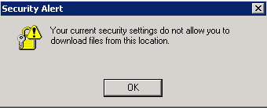
Solution:
Follow the instructions detailed in Appendix E: Adding VBECS FTP Site to the Trusted Sites in Internet Explorer.
The Start button of the VBECS patch is disabled. | 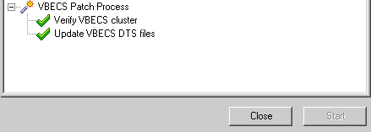
The Start button of the VBECS patch is disabled. | Solution:  The Start button is disabled while the patch is running and after the patch completes.
The patcher’s Remote Desktop Connection was terminated by the patch. | 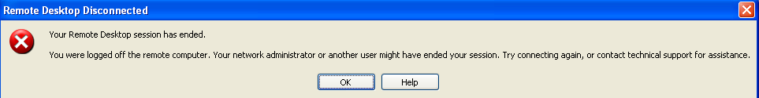
Solution:
You have an active session at the server console (KVM).
Log off your server console session and restart the patch.
The patch has detected a slow data transfer rate. | 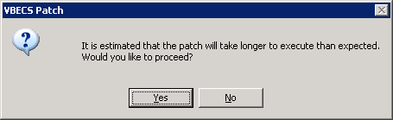
The patch has detected a slow data transfer rate. | Solution:  Verify the cluster network configurations are setup properly. Refer to the VBECS 1.6.0 Technical Manual-Security Guide.  Consult with your Network Administrator for possible hardware problems.  Check Task Manager to verify the Networking and CPU performance metrics.
The files extracted from the zip file were left in a Read-only state. | 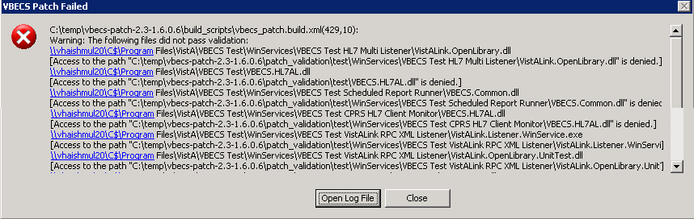
Solution:
Do not skip steps listed in this guide.
Remove the read-only attribute of the extracted patch files.
Refer to the Verify the Contents of the Patch Package file sections, Step 10 Test and Production Environments.
The patch was denied access to an application file. | 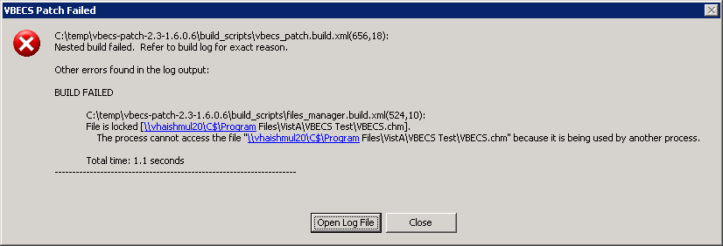
The patch was denied access to an application file. | Solution:  Using Task Manager, verify that all users are logged off the server identified in the message.  Reboot the server if the locked file cannot be identified and released.
The patch detected an active database connection | 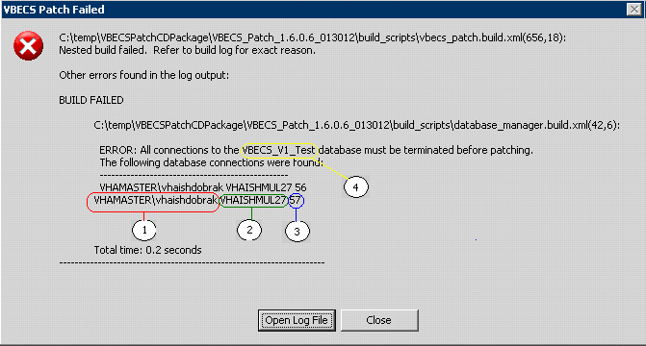
The patch detected an active database connection | Solution:  Close the identified connection/application and restart the patch.  Use the information contained in the message to identify the user/machine connected to the database:  1. User Login ID  2. Computer Name  3. SQL Process ID  4. Database Name
The SQL Server instance detected by the patch could not be reached. | 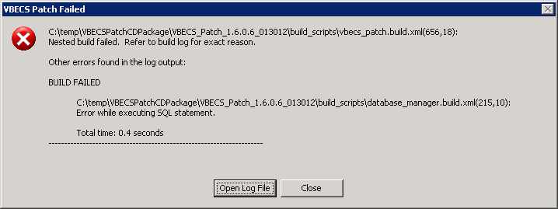
Solution:
Using Cluster Administrator, make sure all of the cluster resources are Online and running on the same node.
Verify you have server administrative permissions to the cluster.
The wrong patch is being executed for the current VBECS build. | 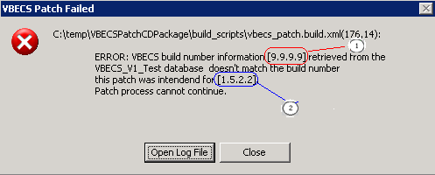
Solution:
Verify you are using the correct patch for your build.
Use the information displayed in the message to identify where the problem lies:
1. Build number found in the VBECS database.
2. VBECS Build number the patch is designed to update.
The patch detected active resources running on the passive node. | 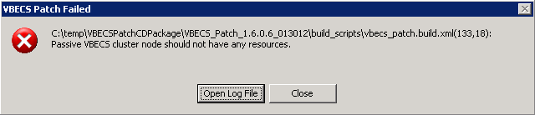
Solution:
Using Cluster Administrator, verify that all resources are running on the same node.
Restart the patch.

Appendix E: Adding VBECS FTP Site to the Trusted Sites in Internet Explorer
- Open a remote desktop connection to the Cluster Node 1 (e.g. VHAXXXNODZ1 or R01YYYNODXXX01).
- Open Internet Explorer and select Tools, Internet Options (Figure 27).
Figure 27: Example of Internet Explorer Window
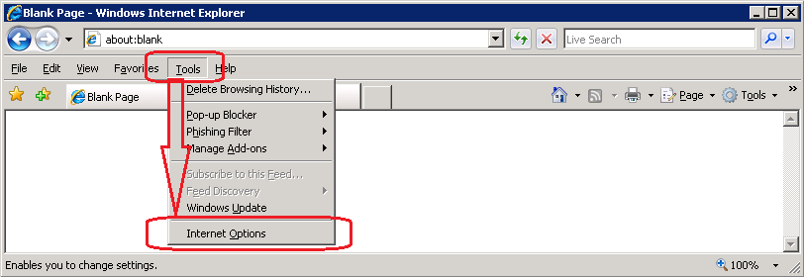
- Select the Security tab (Figure 28).
Figure 28: Example of Internet Explorer Internet Options Security tab
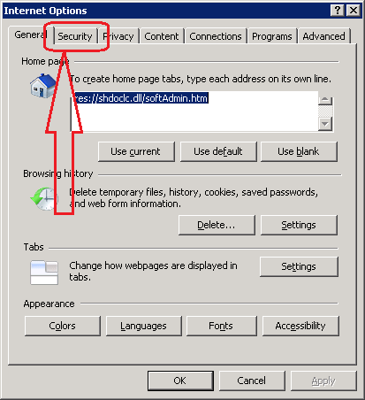
- Select Trusted sites and click Sites (Figure 29).
Figure 29: Example of Internet Options Trusted Sites
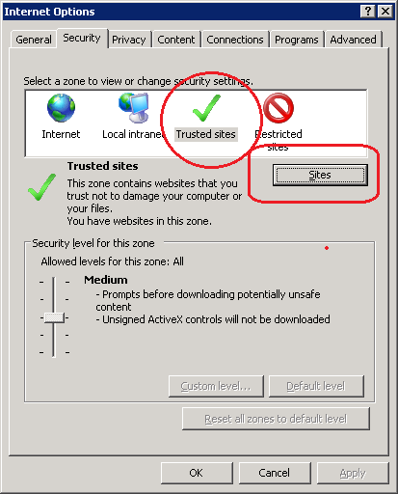
- Make sure Require server verification… is unchecked. Enter ftp://10.3.9.181 and click the Add button (Figure 30).
Figure 30: Adding VBECS FTP to the Trusted Sites
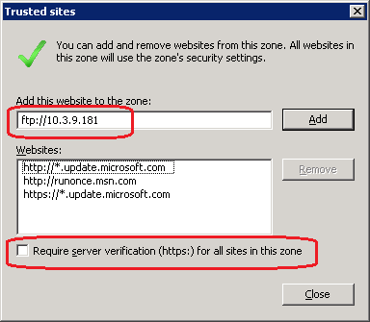
- Close all windows.
- Log off Cluster Node 1.
- Repeat Steps 1 through 8 for the Cluster Node 2 [e.g. (VHAXXXNODZ2 or R01YYYNODXXX02)].
This page intentionally left blank.

Index

C
Completing Patch Installation
Prod 27
Test 17
D
Download the VBECS 1.6.0.7 Patch File
Test 6
Download the VBECS 1.6.0.7 Patch File
Prod 20
E
Executing VBECS Patch
Application Update
Test 13
Executing VBECS Patch
Application Update
Prod 23
H
How This Installation Guide Is Organized 3
I
Installation Logs 31
Installation Procedure for the Production Environment 19
Installation Procedure for the Test Environment 5
Instructions for Capturing Screen Shots for Installation Records 37
Introduction 1
P
Patching Service Monitor
Test 9
Prerequisites for Installation
Production 19
Test 5
Problems? 3
Product Support 3
R
Related Manuals and Reference Materials 1
S
Screen Shots 3
T
Troubleshooting Messages 39
V
VA Service Desk 3
Verify the Contents of the VBECS 1.6.0.7 Patch File
Test 7
Verify the Contents of the VBECS 1.6.0.7 Patch File
Prod 21

This is the last page of VistA Blood Establishment Computer Software (VBECS) Version 1.6.0
Patch Installation Guide.

